FORMER PRESIDENT OLUSEGUN OBASANJO IS ACTUALLY AN IGBO MAN: PATERNITY CONTROVERSY

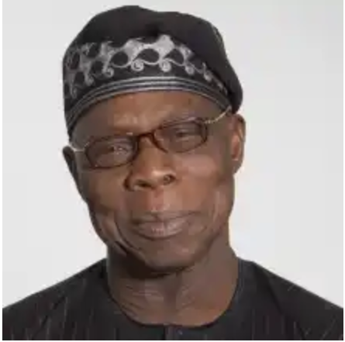
It may sound stranger than fiction, but as daylight melts into darkness, the rumour about Obasanjo’s Igbo roots is gaining currency. Former Abia State governor, Orji Uzor Kalu, had inadvertently teed off the Obasanjo paternity debate when he declared that nobody should use the ex-president’s failings as a yardstick to appraise the competence of Yoruba leaders, because Obasanjo is not a Yoruba man in the first place. But the significance of Kalu’s postulation was lost on many who dismissed it with a wave of the hand.
it may sound stranger than fiction, but as daylight melts into darkness, the rumour about Obasanjo’s Igbo roots is gaining currency. Former Abia State governor, Orji Uzor Kalu, had inadvertently teed off the Obasanjo paternity debate a few weeks ago when he declared that nobody should use the ex-president’s failings as a yardstick to appraise the competence of Yoruba leaders, because Obasanjo is not a Yoruba man in the first place. But the significance of Kalu’s postulation was lost on many who dismissed it with a wave of the hand. However, last week, tales about Obasanjo’s non-Yoruba ancestry received an oriental twist when The Nation of Sunday, 10 June, published what could be regarded as the biggest affront on Obasanjo’s paternity. Slammed on its front page were two identical photographs of Obasanjo with the headline “Spot The Difference.” While on the right was an old photograph of Obasanjo, on the left was what appeared like an old black-and-white photo of the same Obasanjo. To assist the reader, who apparently, would require the services of a graphic artist to spot the difference, The Nation editors provided a caption to illustrate the pictures. “The personality in picture A is not former President Olusegun Obasanjo who is in picture B. But what do both personalities have in common?” The Nation asked.
there needs to be a picture here
The man in picture A, The Nation explained, was an Igbo who lived in the Abeokuta area in the 1930s, about the time Obasanjo was born. According to The Nation, the police officer later became a monarch on a prominent South-Eastern throne. Before then, however, he had interacted fruitfully with the local community and had a brief affair with an Owu lady, before his final exit from the South-West. Though the newspaper did not say more than that, it left little to the imagination. Whatever innuendo was left of the brewing Obasanjo paternity controversy was blown open the next day by the Abuja-based Leadership newspaper via a damning column tagged Olusegun Igbochukwu Obasanjo, authored by Sam Nda-Isaiah. Using the pictures supplied by The Nation as the fodder of his write-up, the columnist released the bombshell. “The editors of The Nation didn’t want to say much, and they have left us to our imagination, but it won’t be from me that you will hear that Obasanjo’s father was Igwe Onyejekwe, a top ranking police officer who became the Igwe of Onitsha in his lifetime. During his controversial reign, the throne was in contention between him and Igwe Okosi II, just as it is today between Igwe Achebe and Igwe Odukwe,” Nda-Isaiah wrote.

Not done with Obasanjo, the columnist went for the kill: “Igwe Onyejekwe, Obasanjo’s daddy, died after the civil war and, like his son, was said to be very cantankerous and quarrelsome.”The columnist intoned that the circumstances of his birth and rejection would have helped make the former president a very bitter and wicked person. He implored Nigerians never to make anyone their leader except they know where he is coming from. “And Nigerians really saw that proverbial wickedness in the last eight years. It is a very wicked man that would increase the price of a litre of fuel by a whopping N10 on his way out of power, simply because he has a pecuniary interest in refineries he had just sold away. It is also a very bad and wicked president that would double the value of VAT on his way out. What does it cost to be nice and kind and empathetic? Nothing! But that’s for normal people. And Obasanjo is far from being normal.” Closing on a comical note, the columnist advised that since Obasanjo loves power so much and is a prince of Onitsha, ‘‘can’t we just simply crown him the Igwe so that he can leave us alone?’’
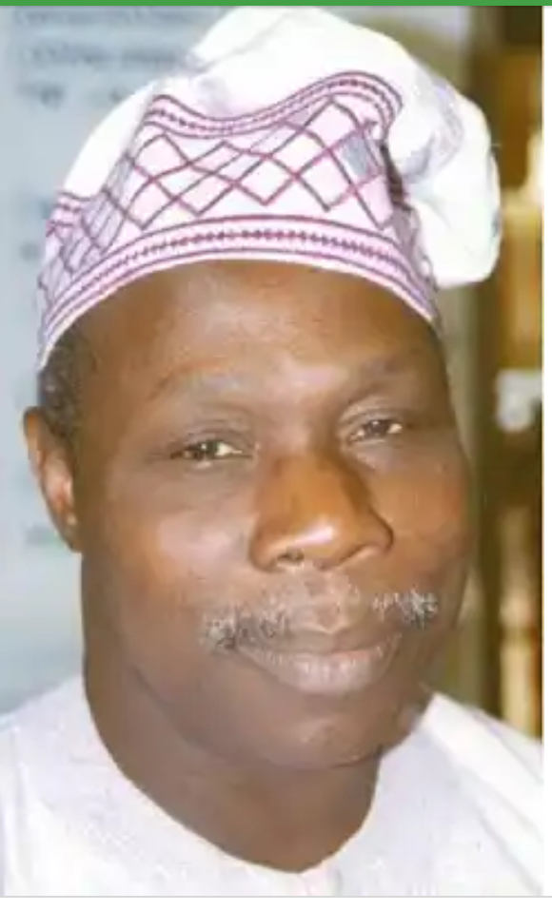
igwe onyekwe, fmr president obasanjo alleged father

But can it be true? Is Chief Olusegun Obasanjo, the Balogun of Owu in Egbaland, be the biological son of Igwe Joseph Okwudili Onyejekwe, the Obi Onitsha Ado N’Idu from 1962-1970? Onyejekwe ascended the coveted throne after the demise of Igwe James Okosi who ruled from 1931-1935. His enthronement came after the report of the famous W.R. Harding Commission, which resolved disputes among the contenders for the throne. If the answers are in the affirmative, does that mean that the Igbo have accidentally taken their eight years ration at the presidency and the Yoruba have not? Oba Isaac Adeyemi Ojelade- Badegunle 1, the Onibogun of Ibogunland, Obasanjo’s reputed maternal hometown, says the rumour peddlers are either callous or are just doing it out of idleness. “It is a big lie, it is nothing but rumours. Obasanjo is a typical Abeokuta man and his father was a pure Egba man from Owu with three facial marks on each side of his cheeks. As a matter of fact, his father came from Abule Elere to Ibogun. They are from Agbole-Olusomi in Abeokuta and I come from his mother’s lineage,” the nonagenarian told TheNEWS.

And on page 84 of the 253-page biography titled: Olusegun Obasanjo in The Eyes Of Time- A Biography of the African Statesman, Onukaba Adinoyi-Ojo, making reference to Obasanjo’s paternity, wrote: “A little over a year after Ashabi’s (Obasanjo’s mother) death, Amos Adigun Obasanjo Bankole passed away following a brief illness. He was buried at Onigbedu where he had remained till the very end. At 22, just when a smile was perching on his face, Olusegun Obasanjo became an orphan.” But the rumour peddlers are far from being convinced. In Onitsha the popular story is that Obasanjo is the product of a romantic liaison between Igwe Onyejekwe and Ashabi, Obasanjo’s mother, in the 1930s. As the story goes, the Onitsha prince jettisoned the idea of taking Ashabi as wife because doing so would hurt his chances of ascending the throne. Another source told the magazine in Onitsha that Onyejekwe actually issued a recommendation that facilitated Obasanjo’s enlistment into the Nigerian Army in 1958. However, in Adinoyi-Ojo’s book there is no mention of Obasanjo requiring recommendation from anyone to join the Army. Yet the proponents of Obasanjo’s Igboship point to a statement credited to him (Obasanjo) during a working visit to Anambra State as confirmation of their claim. Obasanjo had reportedly told an audience in Awka that any of his children is qualified to govern Anambra State. Though the statement was brushed aside then as a gibberish political talk, it has become invaluable with the advantage of hindsight. Whatever anyone chooses to believe, indications are that the rumour mill will remain in overdrive for some time.
CODE - Bhutan6

